# UI Design Revision

Student Design:

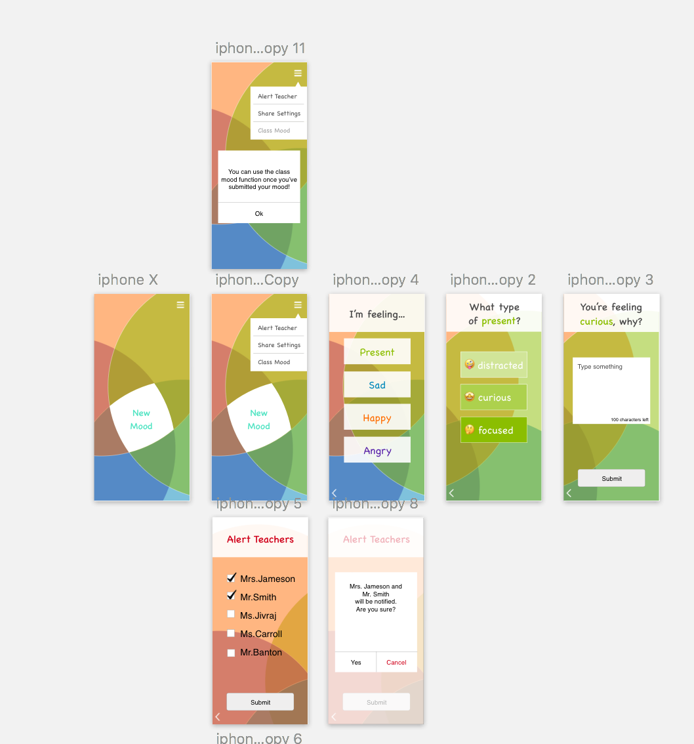

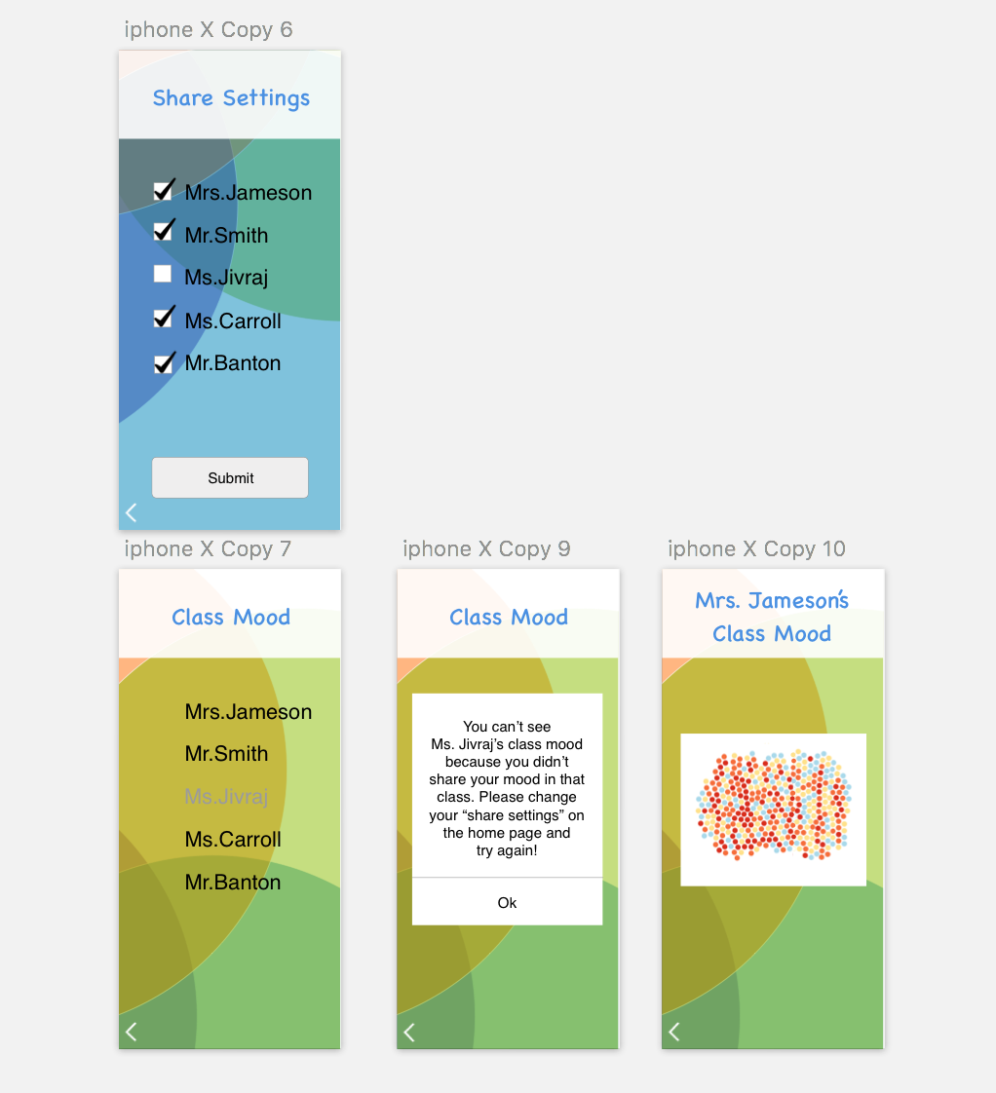

Teacher Design:

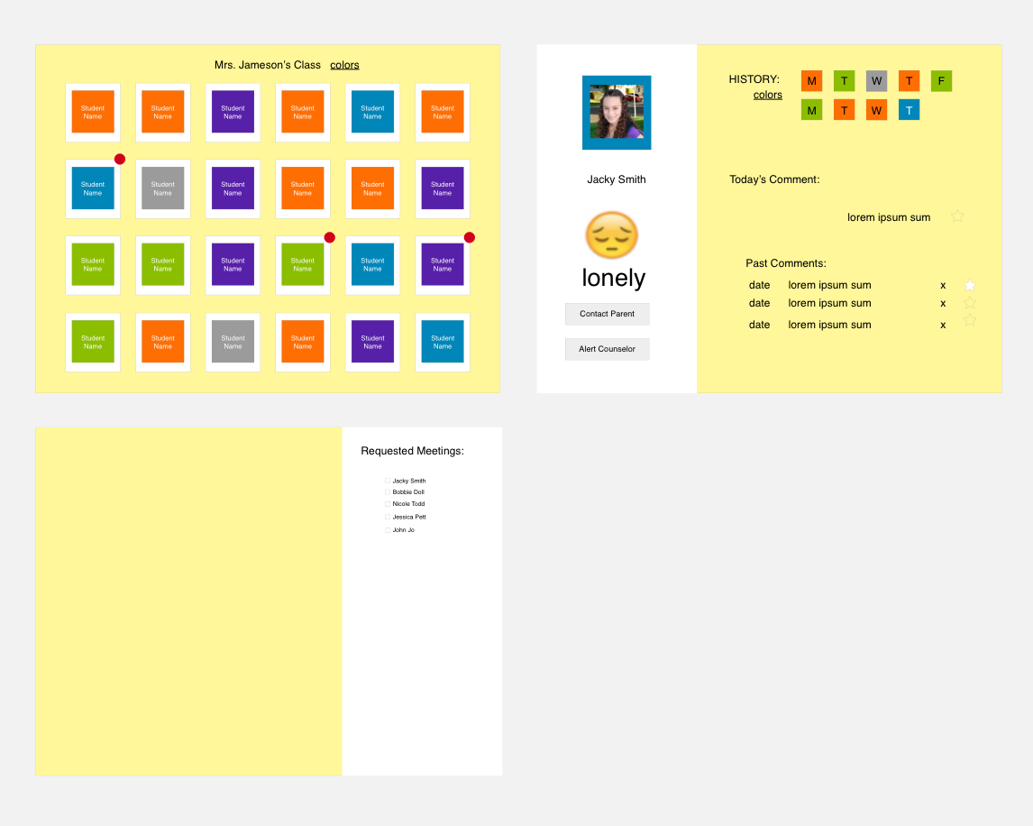

Changes

|  |  |
| --- | --- |
| **Major Changes** | **Problem Solved** |
| Students will be able to access their class’s overall mood. | As motivation for students to input their feelings, additional information about their class is granted as incentive. |
| For details of feeling, student has a single text box with 40 character limit. | “In 3 words” was too limiting while completely open response would be too long for teachers to read. |
| Students can choose who to share feelings with. | Students could have better relationships with some teachers than others. Middle school student said she would only want to share her feelings with her favorite teachers. |
| Replaced slider with percentage of feeling with a choice from 3 words to hone down on specific feeling. | Percentages may be understood as a grade and could skew results. We chose 12 feelings so students won’t be overwhelmed by choices but not feel limited. |
| Student’s feeling and emoji is more prominent on teacher’s view. | It’s easier to glean the most important information. |
| Student’s profile on teacher’s view shows past details students provided on their feelings. | Teachers can read through the details of the feelings their students felt, not just the general color. |
| Teachers can access list of students who alerted them on home page and resolve those issues once they’ve taken the appropriate steps. | A teacher pointed out that there was no way to resolve the issues. Now, teachers can keep track of the meetings that need to happen. |

Coding Deliverables

Implementation Plan: <https://drive.google.com/open?id=1Tjs4NeA-eJsbAAfuiuJL-Q1pNtfzs9VBaKv95ThuJmo>

Code Repository: <https://github.com/jiwhanyoon/spectra-student>

Prototype: <https://jiwhanyoon.github.io/spectra-student/>

(The teacher UI is accessible from the hamburger menu on the student UI homepage. This is only for the practical purposes of hosting a prototype with two separate UIs on one github repo. In reality the student would not be able to access the teacher UI and we will change that before our final hand-in.)